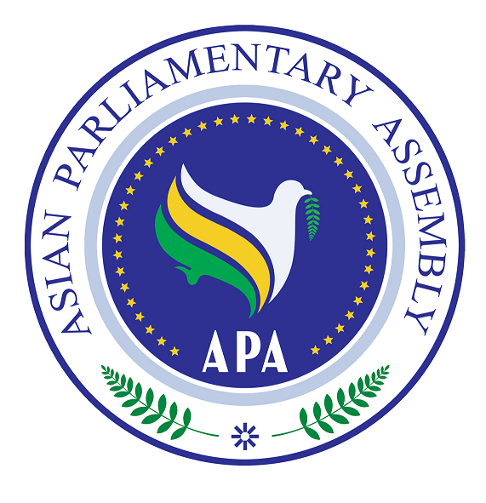  Asian Parliamentary Assembly (APA) | REGISTRATION FORM  Participating in APA Coordination Meeting  At the side of 138th IPU Assembly  9.30-11.30 hours on Saturday, 24 March 2018  Room No. 15, on level-1 of the CICG  Geneva, Switzerland  (Venue of the 138th IPU Assembly)

Please fill in Capital Letters, one form for each individual participating delegate and return to APA Secretariat by 24 March 2018.
- Delegation of: …………

- Title (please check Mr. Ms. Dr., etc.)
- First Name:
- Last Name:

- Position, in the parliament
- ……………………………………………………………………………………

- Phone No. | - …………………..……………………………………………..  - Country Code - City Code - Number
- Mobile No.  - Fax No. | - …………………………………………………………………  - ………………………………………………………………..
- Email Address: | - ……………….……………………………………………..

Any Proposal on Emergency Item:

Please return to APA Secretariat:
Email : secretariat@asianparliament.org
Fax: 009821 - 26118809

